**Project Design Phase-I**

**Solution Architecture**

|  |  |
| --- | --- |
| Date | 18 october 2022 |
| Team ID | PNT2022TMID43250 |
| Project Name | Natural Disasters Intensity Analysis and Classification using Artificial Intelligence |
| Maximum Marks | 4 Marks |

**Solution Architecture:**

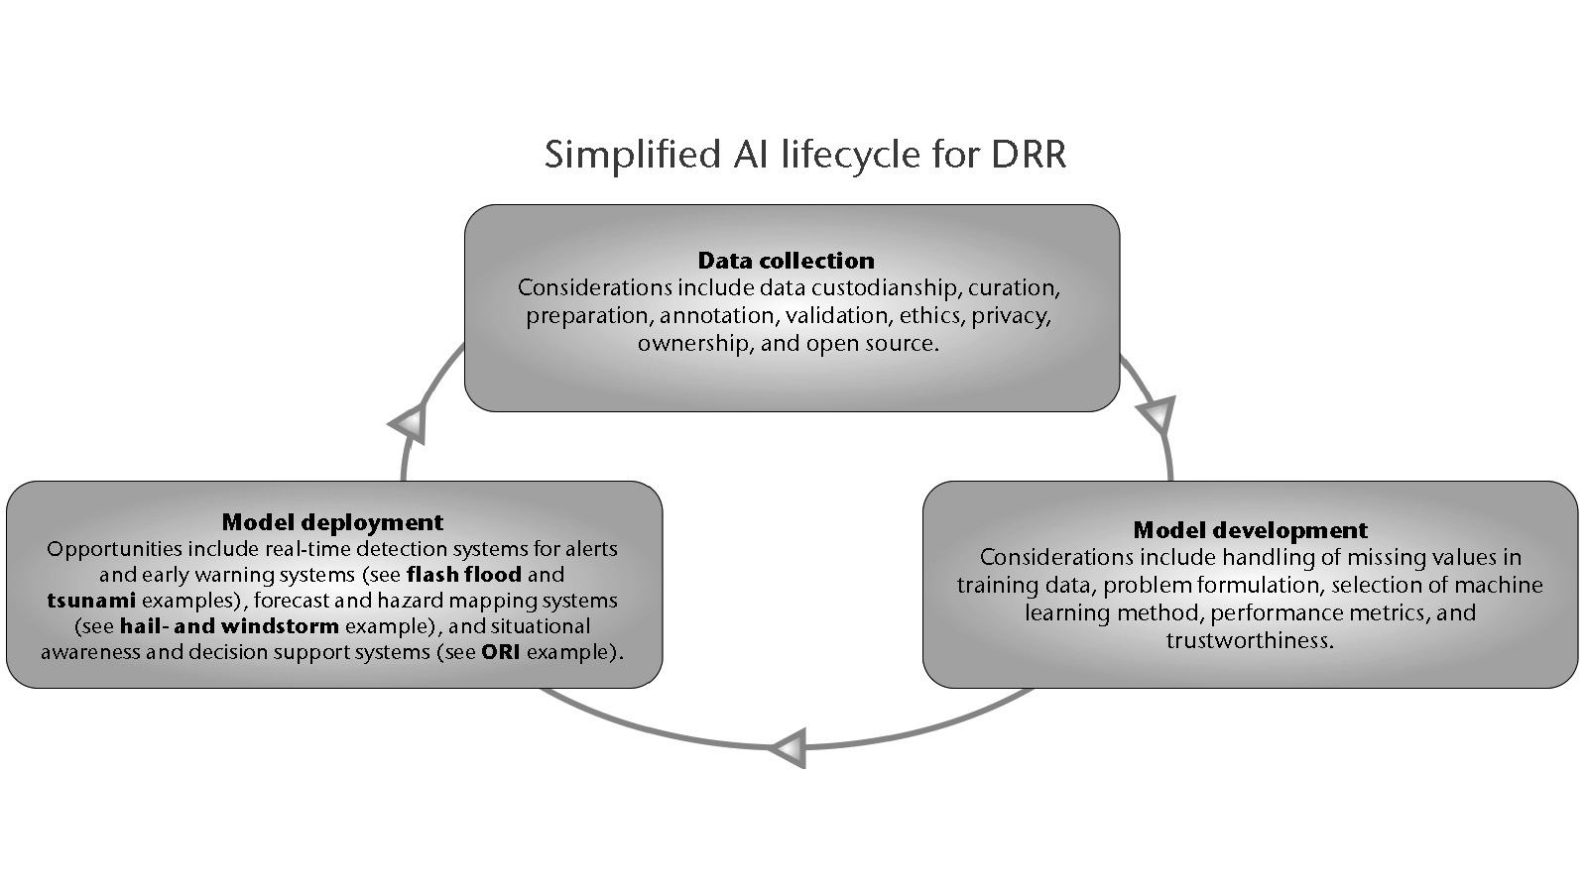

**Example - Solution Architecture Diagram:**

